Table of Contents

1. Introduction 3
2. Evaluation 4
   1. The product 4
      1. Nielsen’s Heuristics for User Interface Design 7
      2. What else could be done 8
   2. The Process 8
   3. The team 9
      1. Team Evaluation 9
      2. Team Justification 10
   4. Self-Evaluation 11
3. Conclusion 12
4. References 13
5. Appendix 14

# Introduction

The objective of the coursework was to work in a scrum team to develop a role-based system. The system will be used to collect student contributions annually at a large university. The goal was to allow various users of the system to perform certain actions within the system. The system is called Swift Magazine and it was designed and developed by the scrum team (Magnificent 5). The team comprises of a Scrum Master, product owner, database engineer, web designer, programmer and a tester. The scrum team worked well together to develop an effective and quality system on time due to documenting weekly meeting minutes, user stories and sprint backlogs. The report will cover the role of the author during the design and development phase of the system. The report will also cover a brief description of the implemented system along with appropriate screenshots briefly explaining the core functionalities of the system. The final product will also be evaluated thoroughly along with future developments that could be implemented into the system and if the product requirements were met. The author will carry out a full evaluation about the process and design methods used, how effective was scrum methodology and how well did the scrum team communicate with one another. An evaluation of each member of Magnificent 5 will be carried out aided with an excel spreadsheet to rate each member of the team. Lastly, an evaluation about the author’s contribution to the team effort, presentation and product will be carried out.

# Evaluation

## The product

The product developed was designed to meet a list of requirements provided by the client. All of these requirements have been met and are observable on the website, which was needed to be created for collection of student contributions, which has been fulfilled. The product was created using PHP as it is relatively fast and easy to use. The key requirements such as submission of articles and uploading high quality images by students were implemented first as this were key functional features that was required by the client of the system. To fulfill the requirements of the system, the scrum team adopted an incremental and iterative approach, which is a fundamental component when using scrum as a development framework for developing a system for a client. The team started by selecting product backlogs that could be achieved in one sprints such as a marketing coordinator making comments based on students contributions and students editing their personal submissions. This allowed room for documenting and testing on these functionalities before working on backlogs that had to be split into multiple sprints.

##### Benefits of the developed system Usability

The product was design to be user-friendly. The group decided on making the colours of the website

homely by using teal and white. This gives unrestricted access to users who have accessibility restrictions such as colour blindness. This use of colour is consistent across all the pages and aesthetically pleasing to the eye.

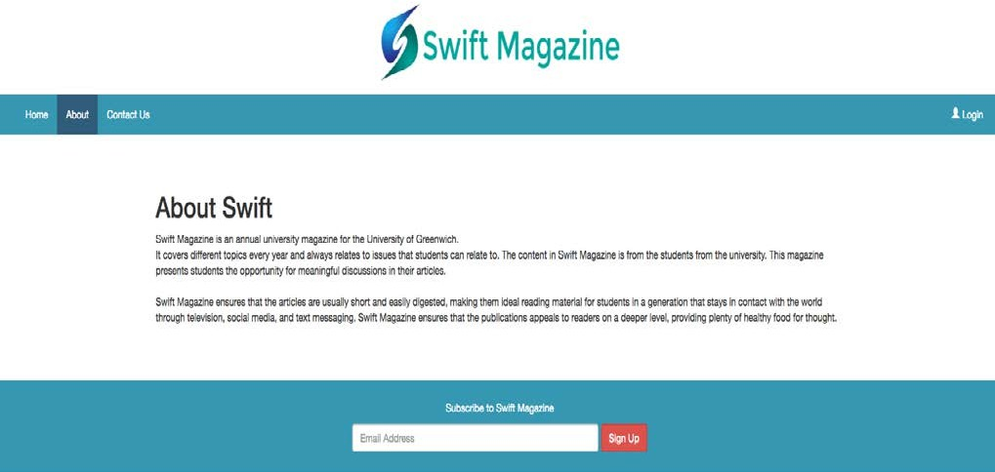

*Fig3. White and Teal colours implemented on the website*

The website can easily be navigated back and forth by a user. They can find their way back if a page was entered unintentionally. This is in support of Nielsen’s user and control freedom that states that *“Users often choose system functions by mistake and will need a clearly marked "emergency exit" to leave the unwanted state without having to go through an extended dialogue.”* (Nielsen, 1994).

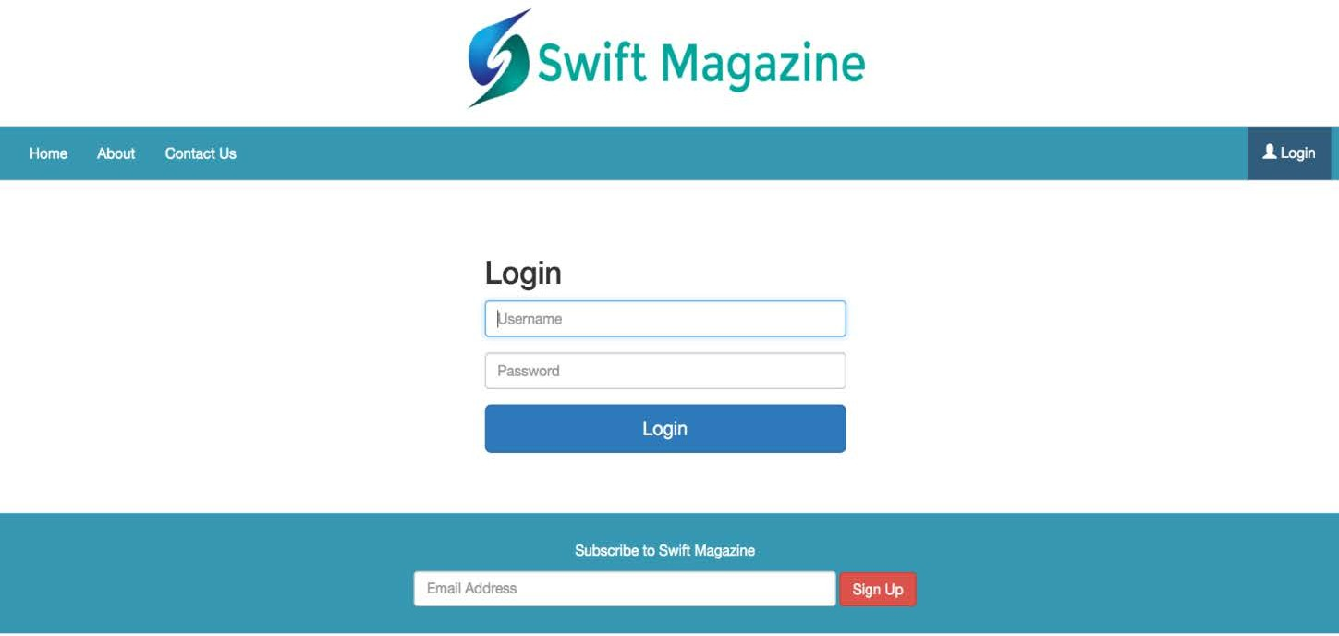

*Fig4. Website showing easy navigation*

One of the client’s requirement was for the marketing manager to oversee the process and view all selected contributions. To enhance this functionality a bit further, a search feature was implemented on the marketing manager’s page to allow him/her to navigate through the submissions easily. This gives the website a distinctive look in terms of usability and easy navigation of the website.

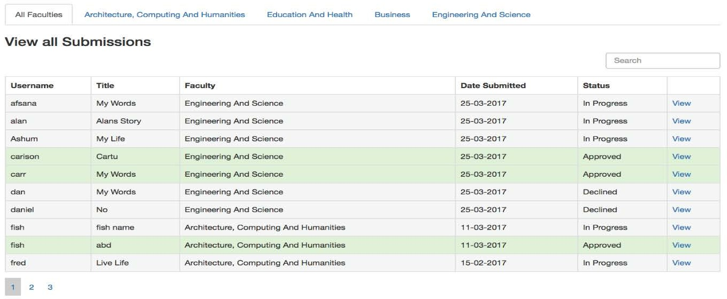

*Fig5. Search feature on marketing managers’ page*

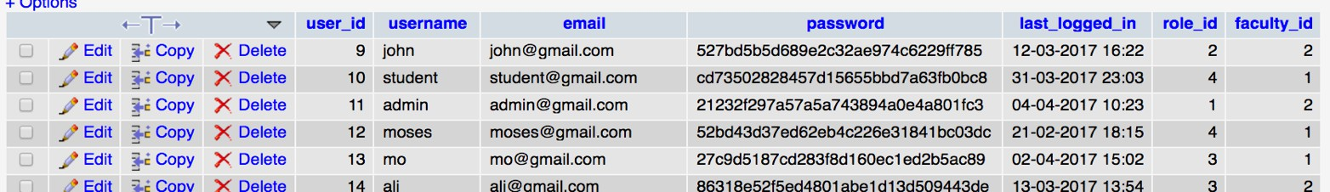

Another requirement of the client is the system’s adaptability to all devices. This criteria was met by making the system responsive to various platforms such as phones, desktop and tablets. A benefit of this is it allows users of the system to view an article across various platforms at anytime.

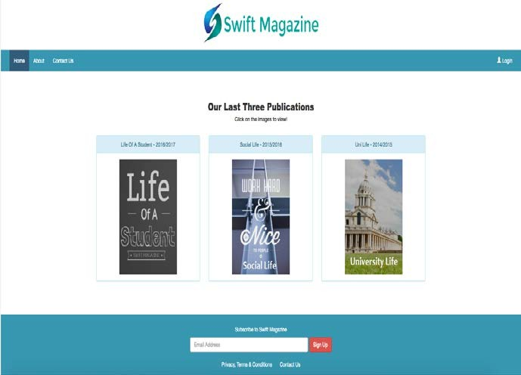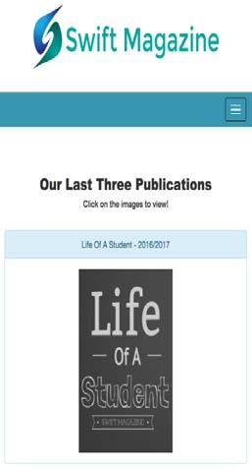

*Fig6. Responsive design on the homepage*

##### Security and Privacy

The system was implemented to offer security measures to thwart unwarranted users from carrying out illegal and unauthorized actions within the system. The data stored within the system has been secured using numerous validations such as the MD5 hash security feature, which was used to encrypt the data in the database. The system was design to follow rigid guidelines to provide the users of the system a website that safeguards their identity and privacy that is frequently abused in role based web applications.

*Fig7. MD5 hash security feature in the database*

The product evaluation will be assess further using relevant Nielsen’s heuristics for user interface design as to rate and identify the effectiveness and efficiency with the product in terms of appearance and usability. The heuristics is shown below.

### Nielsen’s Heuristics for User Interface Design

##### Visibility of system Status – Rating (5)

The website lets a student know the amount of steps it takes them to upload a document. This is in support of the Neilsen’s rule that states, *“The system should always keep users informed about what is going on, through appropriate feedback within reasonable time.” (Nielsen, 1994).* The screenshot could be seen in **(Appendix – P14***).*

##### User control and freedom – Rating (5)

The website allows a student to edit a submission and make changes, which supports the Nielsen’s rule which states “*Users often choose system functions by mistake and will need a clearly marked “emergency exit”* to *leave the unwanted state without having to go through an extended dialogue. Support undo and redo.” (Nielsen, 1994).* The screenshot could be seen in **(Appendix – P14).**

##### Aesthetic and minimalist design – Rating (5)

The website is clutter free and clean and does not take away from the functionalities of the website. This is in support of the Neilsen’s rule that states, *“Dialogues should not contain information which is irrelevant or rarely needed. Every extra unit of information in a dialogue competes with the relevant units of information and diminishes their relative visibility.”(Nielsen, 1994).* The screenshot could be seen in **(Appendix – P15).**

##### Help users recognize, diagnose, and recover from errors – Rating (5)

The website alerts users of the system when they access restricted web pages. A link has been provided on various restricted pages that redirect users to the home page of the website, as it is very vital to help users of the system to recover from this issue. This heuristic principle is in support of Neilsen’s rule that states, *“Error messages should be expressed in plain language (no codes), precisely indicate the problem, and constructively suggest a solution.”(Nielsen, 1994).* The screenshot coul

d be seen in **(Appendix – P15).**

Rating Scale: 1 = Poor, 2 = Fair, 3 = Good, 4 = Very Good, 5 = Excellent

#### Magnificent 5: COMP1640 Individual Report

### What else could be done

If the development of the product were to be continued, a development that would be made is integrating an intelligence tool such as tableau with the system. Statistical reports can be linked to filter data faster and smoother. Tableau would help in showing the general statistics of each faculty using interactive graphs in an organised manner. Tableau can be used to compare the performance of each faculty thereby allowing various strategic decisions to be made such as having the university promote swift magazine for faculties with low performances. Tableau is also adaptable to various devices such as mobile phones which allows statistical reports to be optimized with various devices.

Overall, it could be agreed that the implementation of the product was completed to meet the requirements of the client to successfully attain the maximum performance available through the developed product.

## The Process

The product was implemented using aspects of scrum methodology. The main advantage of using scrum is it saves time and it is iteratively developed through continuous feedback from the client of the system. Another advantage of scrum is it leads to the improvement in the output of the team members due to meetings and collaboration. For the product to be successful, a team of five was chosen and assigned with roles suited to their strengths. The team used various techniques to ensure that there was constant communication with one another. One of the techniques used to execute this was the use of weekly scrum meetings. This is where the team meets up at the same location and time every week where each member of the team talks about tasks that has been completed prior to the meeting and tasks that needed to be completed before the next meeting. The team also documented a weekly meeting minutes that have the location, time and actions that took place over that particular meeting. Another technique that was exploited was the use of user stories. The team documented the user stories on trello, which highlights the functionalities that each user of the system will carry out.

Another technique that was used to develop the system was designing a product backlog to help the team identify all the functionalities that needed to be implemented in the system. Each individual member agreed on what backlog could be done in the first sprint, which was the login feature. The group came up with an assumption, which was later added to the backlog. During the development, new functionalities were added to the list along the way. Ten percent of the scrum team’s total time was retain for preserving the backlog as this helps in sorting out each requirements for weekly sprint planning.

Overall, the team communicated well with one another throughout the development phase. The use of user stories and product backlog aided the team throughout the product’s life cycle. In thus meeting the criteria for using the scrum framework and successfully exploiting it to develop an effective system.

## The team

### Team Evaluation

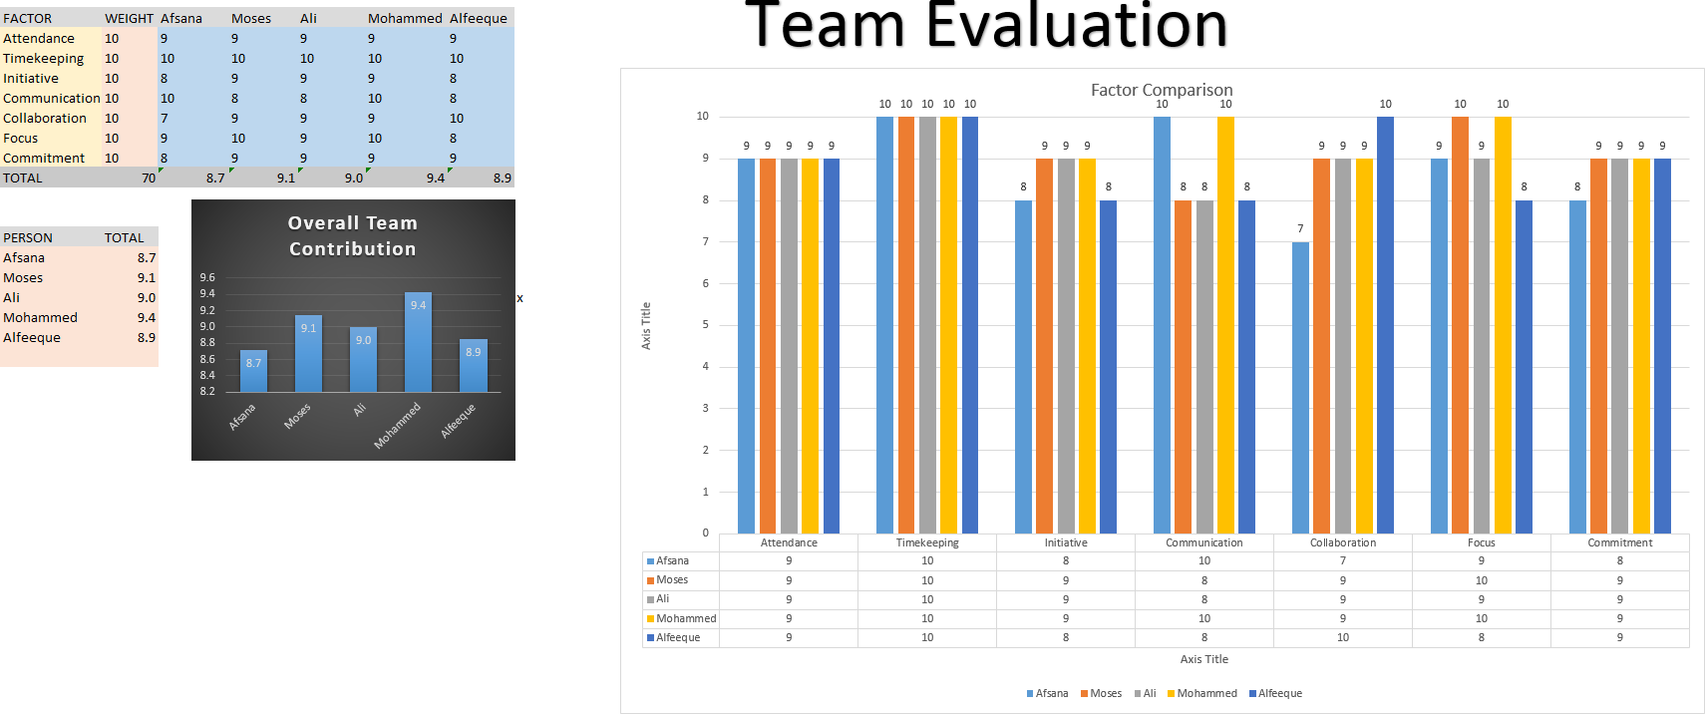

*Fig12. Team Evaluation*

Page **9** of **15**

### Team Justification

|  |  |  |  |
| --- | --- | --- | --- |
| **Name** | **Factor** | **Average Rating** | **Comments** |
| Afsana | Attendance:**9** Timekeeping:**10** Initiative:**7** Communication:**10** Collaboration:**7** Focus:**8**  Commitment:**8** | **8.7** | Afsana attended scheduled weekly meetings with the team, as the product owner, she motivated the group and accepted criticism from the team gracefully. She also collaborated fairly with the team and made sure each tasks was completed on time. As the product owner, she communicated clearly with the group and made sure each member worked cooperatively with one another. |
| **Moses(Author)** | Attendance:**9** Timekeeping:**10** Initiative:**7** Communication:**8** Collaboration:**9** Focus:**9** Commitment:**9** | **9.1** | Moses was the database engineer of the team, as such; he collaborated well with the programmer in developing the system to a high standard. He attended weekly meetings with the team and communicated well with the team about his progress in designing the entity relationship diagrams and population of the database. He was fully committed to the project and approached each tasks assigned to him diligently. He contributed to the development of the project regularly and worked well with others. |
| Ali | Attendance:**9** Timekeeping:**10** Initiative:**7** Communication:**8** Collaboration:**9** Focus:**7**  Commitment:**9** | **9.0** | Ali fully understood the requirements for the product. He was assigned the web designer role because it was suited to his strength. He collaborated extremely well with the programmer by working cooperatively well in making sure the designs of the product was of a high standard. He also made frequent suggestions and showed interest in the decision making of the project. |
| Mohammed | Attendance:**8** Timekeeping:**10** Initiative:**9** Communication:**8** Collaboration:**9** Focus:**8**  Commitment:**9** | **9.4** | Mohammed carried out various tasks with the product without overly relying on other team members. He also displayed a positive attitude and contributed his fair share to the development of the product. As the programmer of the team, he identified any problem with the product and worked towards a viable solution quickly and efficiently. He collaborated well with every member of the team and sought feedbacks frequently from  the client of the system. |
| Alfeeque | Attendance:**9** Timekeeping:**10** Initiative:**7** Communication:**8** Collaboration:**9** Focus:**7**  Commitment:**9** | **8.9** | Alfeeque was the scrum master of the group; he was present at all but one meeting. As the scrum master, he always had a positive attitude and had good leadership skills. He was very creative in his approach to various problems with the development of the product. He followed through in completing his assigned tasks to the product. He contributed to discussions about the product from time to time. |

## Self-Evaluation

My contribution to the team effort was extremely extensive as I was tasked in designing the database. I was chosen by my teammates to be the database engineer as they believed I had the best experience with databases, as such, I was best suited to take on the role of the database engineer. One of my many responsibilities was to design the entity relationship diagram. Due to previous experiences with designing database diagrams in my first two years at the university, I was extremely confident in taking the role and well prepared for the challenges ahead.

As the database engineer, I started off by designing a conceptual entity relationship diagram composed of entity types and identified the relationship between the entities. Due to constant feedback from the tutor, I had to make slight changes to the model by making it enhanced. I had to implement a super class and various subclasses for better representation of the entity types. I also had to implement a logical model and identify the attributes, foreign keys, and cardinalities between different entities, which was then transferred on to MYSQL database. I consulted with the rest of the team to find out which database will be best suited for the project. We all agreed on using MYSQL due to prior experience with the database management system and also found out the team’s preferred scripting language (PHP) gels well with MYSQL. I had to work closely with the programmer of the team in entering the entities and populating data into the database. I also had to make sure the right data was populated and validated. The programmer suggested in using the MD5 algorithm for security purposes.

It was important we follow every aspect of scrum for the project to be successful; the next task was to make a start on the user stories. The scrum master and myself was chosen by the team to make a start on it because the rest of the team felt we understood it much better. The first user stories were drafted on Microsoft word document before transferring it into a professional project management application known as trello. I also had to work alongside with each member of the team on developing the product backlogs. Each backlogs were entered as they are being implemented into the system. Some of the backlogs had to be split into multiple sprints, as they require longer implementation time. I also attended all weekly meetings and followed through in completing tasks that was set in the meetings. I also made some suggestions to the web designer and participated in working towards better improvements with the system designs.

My preparation for the presentation was comprehensive; I had a lot of practice session with the team because we all felt I needed it the most to help me with my anxiety. I suggested we speak on the benefits of the system rather than demonstrate the functionalities of the system. Another team member suggested we speak a little about the functionality, as this will allow the audience to understand the system better. My part of the presentation was to talk about the responsiveness and adaptability of the system. I felt I sold the system as I spoke about the benefit of the system being responsive due to the fact; it saves the client of the system the expenses of having two websites on different platforms. In future if I was to take on this role, I will improve by communicating and work even better with the team more effectively.

Overall, this was a fascinating module, in which I gained various skills such as effective use of time, leadership skills and collaboration with other team members. The lecturer and the tutor were helpful throughout the duration of the module and without their help; I would not have successfully completed sections of the coursework to the standard expected of me.

# Conclusion

This report has evaluated the undertakings of “Swift Magazine” life cycle reporting all the relevant parts within the product. It should be noted that the product was delivered within the deadline given with all the functionalities implemented. This was achieved by following all aspects of scrum methodology such as weekly scrum meetings, documenting a product backlog and user stories to highlight the features of the product. In the first section of the report, the product was evaluated along with appropriate screenshots and commentary. The benefits of the system were discussed in terms of security and usability of the system. Nielsen’s heuristics for user interface design was used to aid the product evaluation section as a guide in rating the effectiveness of the product in terms of usability and appearance. The report also discussed a future development that could be implemented into the system, which was integrating tableau into the system for better visualisation of statistics. In the second section of the report, the process used to develop the system was evaluated on how well the scrum team communicated with one another and what design methods was used. This section touched on how well the team used scrum techniques to develop an effective system. The use of product backlog and user stories aided in developing the product and made sure it was delivered on time to the client. The team “Magnificent 5” was evaluated in this section. Each team member were assessed by using an excel spreadsheet to rate them using various factors of teamwork. This was supported by comments justifying the ratings of each member. Finally, a personal evaluation of the report was carried out explaining the author’s contribution to the team effort, product and presentation. Overall, it could be concluded that an extensive evaluation of all aspects of the product life cycle has been carried out thoroughly and efficiently.

# References

Nielsen, J. (1994). *Usability Engineering.* San Diego: Academic Press. p. 115–148.

# Appendix

*Fig8. Website showing the steps it takes to upload a document*

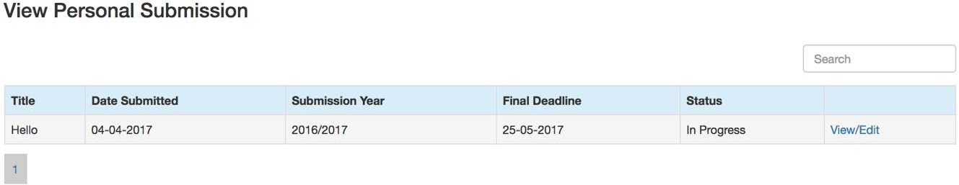

*Fig9. Edit feature on the website to that allows a student to make changes to their submission*

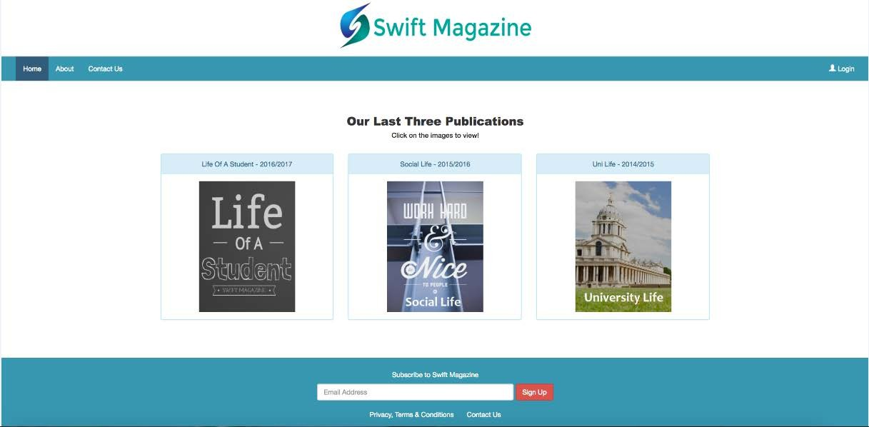

*Fig10. A neat and clutter free homepage*

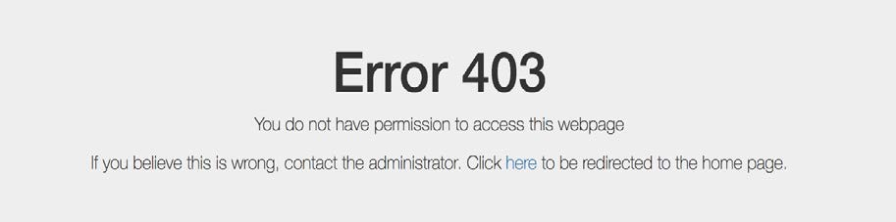

*Fig11. A restricted page with a link that redirects a user back to the homepage*